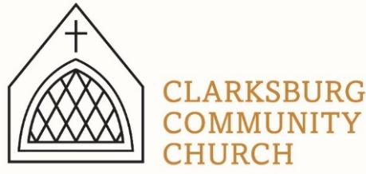
Non-Profit
Bulk Mailing
Clarksburg, CA
95612
Permit #1
Third Class
Chimes
PO Box 36 Clarksburg, CA 95612
52981 Netherlands Ave
November 2023

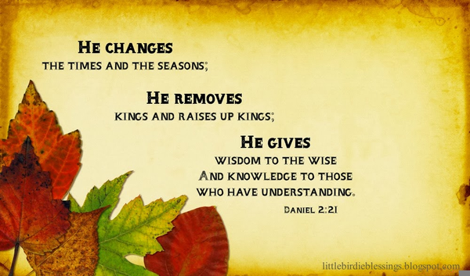

Clarksburg Community Church
Things to Know:
Announcements:
- Join us on Sundays at 9:00 am for Sunday School. Kids upstairs, and Koinonia Café for everyone in the Community Hall with coffee and fellowship.
- Women’s Bible Study meets every Tuesday at 9:30 a.m. to study “100 verses Everyone Should Know.”
- November 4: Church Workday, 9:00 a.m.
- November 5: Daylight Saving Time ends. Fall back one hour.
- November 11: Men’s Group, 7:00 a.m. Breakfast is served.
- November 12: Clarksburg Race Day. Worship moved to 4:00 pm
- November 13: Women’s Ministry event from 6:30-8:00 p.m.
- November 19: Annual Budget Meeting following the service.
- December 3: Advent Sunday School Class begins
- December 17: Children’s Christmas Concert at 10:00 a.m. and “The Thrill of Hope Concert” at 6:00 p.m.
- December 24: Christmas Eve Service, 7:00 p.m.

Church Contact Information
- Church Office: 916-744-1422; Email: information@clarksburgcc.org
- Pastor Sandy Adams, Jr. – pastorsandy@clarksburgcc.org
- Director of Youth Ministries - Aundriea Montzingo, youth@clarksburgcc.org
- Administrator & Children’s Ministry Director, Tiffani Taylor tiffani.taylor@clarksburgcc.org
- Tiffani’s office hours: Monday, Thursday, and Friday from 9am-1pm.

*Visit our website, clarksburgcc.org, for up-to-date information and to worship with us online. Follow us on Facebook and our YouTube page, “Clarksburg Community Church.”
Race Day and Potluck
Sunday, November 12 is the Clarksburg Country Run. Our worship service will be moved to 4:00 pm with the Soups, Salads, and Sides Dinner to follow. Please bring an item to share and enjoy fellowship with the church family.

Kid’s Christmas Craft Party
Parents, put December 3rd on your calendar for
an afternoon off! Drop your kids off at the Community Hall from 3:00 – 5:00 p.m. for
ornament making and Christmas fun hosted by
our Youth Group. Snacks and crafts will be provided and all kids are welcome!

Oasis Youth Group
Calling all 7th – 12th graders! Youth Group schedule:
- November 12: Race Day, no youth group. Worship at 4:00 p.m.
- November 19: Thanksgiving party
- December 3: Babysitting Night, 3:00 – 5:30 p.m.
- December 10: No Youth Group
- December 17: Christmas Party

Christmas Decorating Party
The Worship Committee is hosting a Christmas Decorating Party on Sunday, November 26th at 3:30 p.m. Come join the party as we decorate inside and outside the building for Christmas! Sonrisa Hanna will be taking over the leadership of this effort from Tressa Dahlberg. Special thanks to Tressa, and her husband Bo, for their many years of service to the church decorating for Christmas.

In Memoriam
Our deepest condolences to the families of the following who recently passed away:
•Catherine Joy Gorter on June 1st
•Vola Johnson (76) on August 6th
•Justin McAllister (19) on September 11th
•Sandra Jones (75) on September 16th
•Dennis Updegraff (66) on October 4th
(Share a memory about Dennis at dignitymemorial.com and search Dennis Updegraff.
Donations can be made at www.gofundme.com/f/dennis-updegraff.)

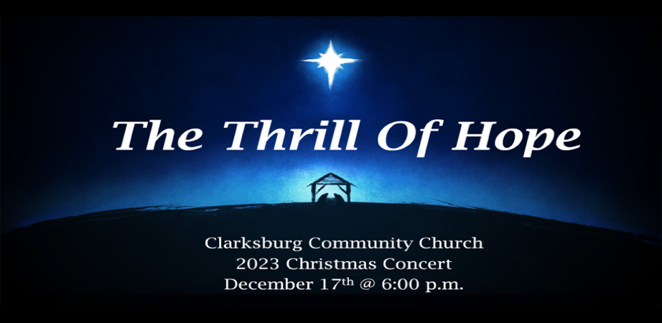

“Chiming In w/ Pastor Sandy”
For many of us, 2023 has been a challenging year. On May 29, my brother and only sibling died unexpectedly at the age of 47 after a brief sickness. Our church family experienced several losses including one of our trustees and members of the Worship Team, Dennis Updegraff. Grief, sorrow, and concerns about global conflicts can either contribute to us longing for hope or losing it.

Advent is a wonderful time to address the hurts of each year and help us refocus on the hope we have in Jesus. Please join us for worship and the special events we have planned this season. In spite of your heartaches, you can rediscover the thrill of hope this Christmas.

Advent Sunday School Class
Beginning December 3rd and continuing through the 24th, this year’s Advent Sunday class will work through the study Eternal King Arrives. The class is open to all ages and each household will receive a free devotional booklet. The Koinonia Café opens at 8:45 and Sunday School begins at 9:00.
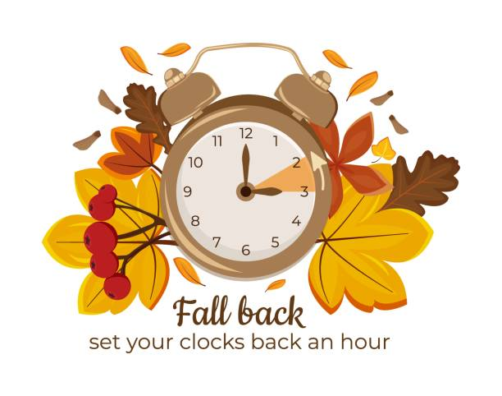
Don’t Forget! Time Change November 5!

