Non-Profit
Bulk Mailing
Clarksburg, CA
95612
Permit #1
Third Class
Chimes
PO Box 36 Clarksburg, CA 95612
52981 Netherlands Ave
February & March 2024

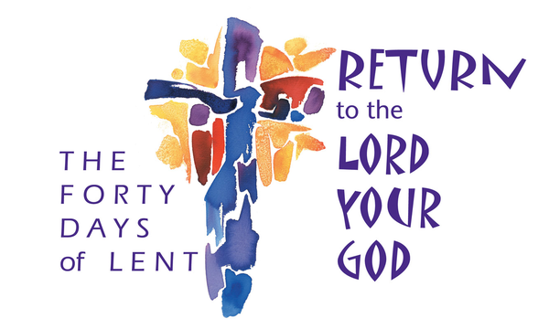
Clarksburg Community Church
Things to Know:
Announcements:
- Kids Sunday School and the Koinonia Café Sundays at 9:00 a.m.
- Tuesday Ladies Bible Study, 9:30 a.m. - 100 Verses Every Christian Should Know.
- The Knitters Club meets Thursday from 10:00 a.m. - noon in the Music Room.
- Men’s Group: February 10 and March 9 at 7:00 a.m. in the Community Hall.
- Women’s Ministry Events: Monday, February 19 from 3:00 – 5:00 p.m. for an afternoon tea and March 18 from 6:00 – 8:00 p.m.
Lent Schedule
- March 24, Palm Sunday, the youth choir will sing in the 10 a.m. service.
- March 28, Maundy Thursday Service at 7:00 p.m.
Easter Sunday, March 31
- Sunrise Service at 7:00 a.m. at the Scout cabin firepit
- Easter morning service at 10:00 a.m.
- Easter egg hunt for children following the 10 a.m. service
2024 Vacation Bible School: June 10-14
Dive into an amazing undersea adventure where kids experience the love of God and friendships are made. We need helpers for a variety of roles from 7th grade through adults. Please email tiffani.taylor@clarksburgcc.org to volunteer.

Church Contact Information:
- Office: 916-744-1422; Email: information@clarksburgcc.org
- Pastor Sandy Adams, Jr. - pastorsandy@clarksburgcc.org
- Director of Youth Ministries - Aundriea Montzingo, youth@clarksburgcc.org
- Administrator & Children’s Ministry Director, Tiffani Taylor - tiffani.taylor@clarksburgcc.org
- Tiffani’s office hours: Monday, Thursday, and Friday from 9am-1pm.

*Visit our website, clarksburgcc.org, for up-to-date information and to worship with us online. Follow us on Facebook and our YouTube page, “Clarksburg Community Church.
Easter Eggs Needed!
The Children’s Ministry will once again be hosting a HUGE Easter Egg hunt following the 10:00 a.m. Easter service. Therefore, we are in need of plastic eggs, both filled and empty by March 17. Please bring
your donations to the church office.

Union Gospel Mission Winter Drive
The following items are needed for Sacramento’s Union Gospel Mission’s Winter Drive by February 27. Please place the items in one of the bins near the kitchen. Contact Dee Smithers for more information about the drive or to volunteer at the mission.
•Blankets •Tarps
•Sleeping bags •Men’s Socks
•Men’s Belts (Lg - XL) •Toiletries (includes men’s combs)

Oasis Youth Group
The Oasis youth group has been diving into an exciting series titled “Better than Basic.” With school and life back in full swing it is so important to remember that God is the center of it all. We encourage all 7-12 graders to come and hear the Word of God, play games, have snacks and make lasting new friendships. We meet Sundays from 4:00-5:30 p.m. at the church. Summer camp information coming soon! Any questions or comments -Aundriea Montzingo, Youth Director, youth@clarksburgcc.org.

“Chiming In w/ Pastor Sandy”
The scheduling of Easter has always been frustrating for me. Unlike other holidays that take place on a specific date or day of the month, Easter is a “movable feast” annually occurring on a Sunday from March 22 through April 25. The lunar cycles, as well as other confusing factors, are the reasons for the range of possible dates for Easter’s schedule. Truth be told, I have not enjoyed Easters that took place in March as much as in April. My reasoning has been a March Easter is too close to Christmas, which limited my enjoyment of Christianity’s most significant holiday.

With the time between Advent and Lent being shorter this year, I am making a Lenten resolution: rather than be frustrated by Easter’s early date for 2024 I am focusing on the hope expressed by the Paschal Greeting, “He is risen! He is risen indeed.” That statement is true no matter what season it is, making Easter a daily holiday for believers in Jesus, whether it takes place in March or April.
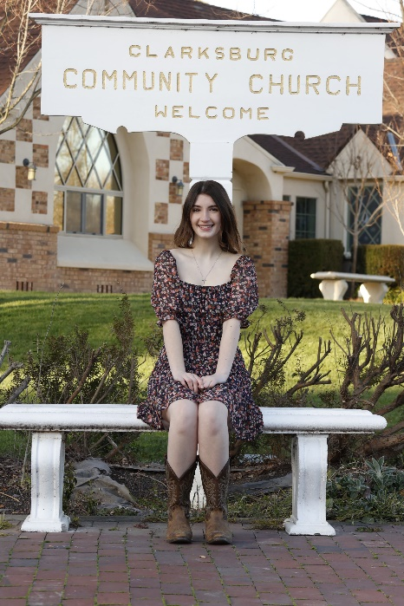
Mission Moment
Hi, my name is Abigail Morazzini. I've grown up in Clarksburg Church, am a recent Delta High graduate, and now attend Concordia University Irvine. I have the opportunity to go on a mission trip to Hungary this summer and will live and work with other college students, teaching the Gospel and English to Hungarian children. I am very humbled and excited for this chance to teach others about Jesus! Please consider supporting me in prayer, for safe travels and meaningful connections with the children. If you are able to support me financially, donations can be made to Clarksburg Community Church with "Hungary Mission Trip" noted in the subject line. These donations are tax deductible and will help to cover my travel and lodging costs. I am so grateful for any support and all the prayers! I can't wait to tell my church family all about the trip!

“Honoring Marriage” by Raquel Rapp
Several years ago, former pastor Dennis Montzingo preached a sermon on marriage and at the conclusion asked, “what will you do to honor marriages?” My response was that I purposefully hung a large picture of Tim & me on our wedding day in a place where I see it daily. This and other wedding day memorabilia around the house are reminders that God is the reason we continue to be held together. Over the years, I’ve wondered how to honor other marriages and recently shared with Pastor Sandy about highlighting wedding anniversaries in the church. So, congratulations to the following couples who have recently celebrated wedding anniversaries:
•Nelson & Michelle Bonilla: December 15 (22 years)
•Bill & Sharon Brown, January 18 (39 years)
•Don & Julie Harmon, February 14 (15 years)
•Peter and Lisa Finn, December 26 (36 years)
•Zack & Becky Morazzini, December 28 (27 years)
•Mark and Vicki Pruner, January 3 (26 years)
•Greg & Maria Rowsey, January 8 (41 years)

Daylight Saving Time begins Sunday, March 10 at 2:00 a.m. Set your clocks ahead one hour!

