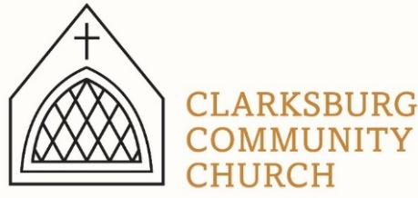
Non-Profit
Bulk Mailing
Clarksburg, CA
95612
Permit #1
Third Class
Chimes
PO Box 36 Clarksburg, CA 95612
52981 Netherlands Road
April/May 2021

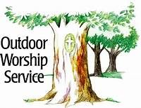
Outdoor worship is coming back to Clarksburg Community Church for July and August. Join us at 10am on the lawn for an uplifting time of worship and fellowship!
Clarksburg Community Church
Things to know:

May and June Schedule
- Men’s family BBQ, May 13 at 5:30 pm at Heringer Estates
- Church Work Day- May 22 at 9:00am
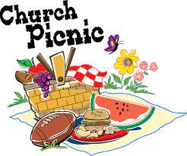
- VBS, June 7-11 from 9:00am -11:30am
- VBS Sunday and Church Picnic – June 13 following the 10am service

All Church Picnic
Dust off that favorite summer recipe and those ice cream machines! The annual All Church Picnic will be June 13th following the Sunday morning service. Join us for a delicious pot-luck lunch, good fellowship and homemade ice cream.

Teen Summer Camp
Summer camp is June 20-26 at Heavenly Hills for students in grades 7-12. We are excited to be sending our youth to a new camp this year up near Twaine Harte. This is a great time for teens to create friendships and learn about our amazing God. There are tons of outdoor activities and fun! Email Amanda at cbccyouth1@gmail.com for more information on how to register your teen!
Contacting Clarksburg Community Church
The church office is open Monday and Thursday from 9am-1pm or by appointment.
Office Phone: 916-744-1422 or email information@clarksburgcc.org
Pastor Sandy Adams: pastorsandy@clarksburgcc.org
Youth director Amanda Aragon: cbccyouth1@gmail.com

Congratulations to the class of 2021!
We would like to congratulate the seniors of the class of 2021 from CCC. Cambria Reynolds, Ryan Fantuzzi and James Clark will be graduating from Delta High School on June 3 at 7 o’clock. Due to limited seating there will be a live stream of the graduation and a cake reception at the church following the ceremony.
Clarksburg Community Church will also be hosting a baccalaureate on June 1st at 7:00 pm. Seating will be limited.

Church Work Day
Everyone is invited to attend our Spring work day on Saturday, May
22nd. Starting at 9:00AM. We'll be sprucing up the grounds for our annual picnic. Bring your yard tools and gloves!

From the Church Moderator
Over the past several months, the Church Council has investigated a possible change in our denominational affiliation. For over years 60 years, Clarksburg Community Church has been a member of the United Church of Christ (UCC). Over that time the UCC has changed in many ways and the Council has decided it was time to examine whether our goals, beliefs and focus are still a good match with them.

The Council formed the Denomination Review Committee to investigate a new denominational affiliation for our church. The committee was tasked with the goal of offering to the Council a recommendation of one of three options: 1) remain affiliated with the UCC; 2) become an independent congregational church; or 3) affiliate with another denomination.

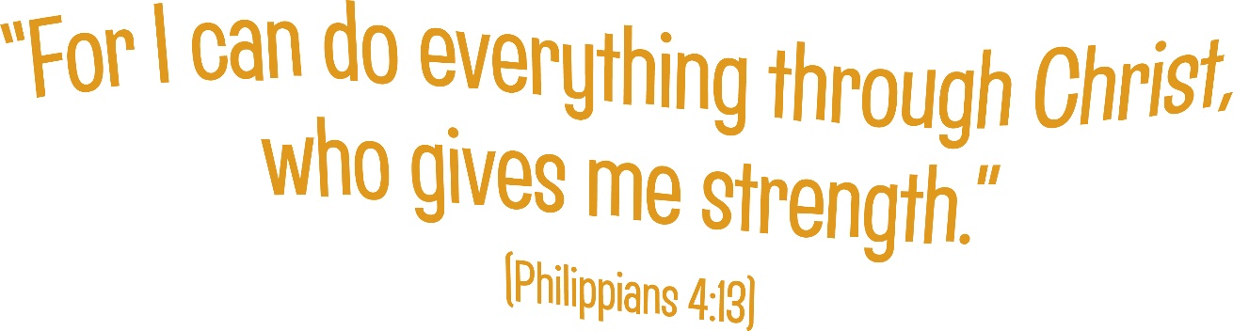
The committee is preparing to finalize its recommendations to the Council in the near future. At some time, the Council will submit a proposal to the church for vote. Please submit all questions, comments or suggestions to Pastor Sandy Adams or Bob Bartron.

In Memory
Our sympathies go out to the family of Paul Grose who passed away March 15. His positive attitude and willingness to help will be missed.

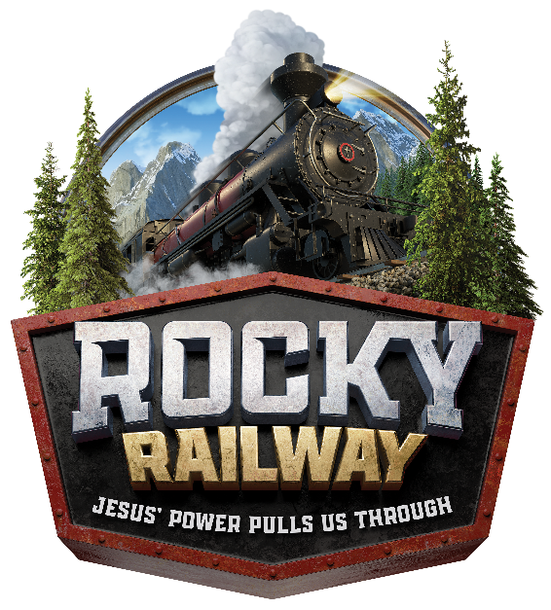
Registration is Open!
VBS 2021 is coming down the tracks, June 7-11 from 9:00 am – 11:30 am each day here at CCC.
VBS is for incoming Kindergarten – 6th graders.
Visit the church website to register, at www.clarksburgcc.org

We are still in need of middle school and high school volunteers! Please register as crew leaders online.
We also need a couple adult leaders for crafts, games and the Bible story station. If interested email Tiffani at tiffani.taylor@clarksburgcc.org

