Clarksburg Community Church
Chimes
PO Box 36 Clarksburg, CA 95612
52981 Netherlands Road
November 2020

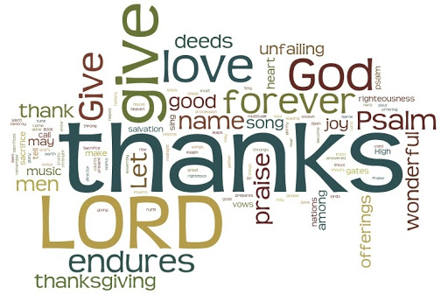

Clarksburg Community Church
Things to know:

November Worship Schedule
CCC will continue with outdoor worship services in November as long as weather permits. We anticipate needing to move indoors mid-November and are planning for 25%-50% capacity services in compliance with county regulations. The Church Council has formed a committee that will oversee safety and is planning for our indoor return. Ushers will seat people, face coverings will be mandatory and all exits will be utilized to maintain social distancing. All services will be available online for those who wish to watch from home. Our technology team is working hard to update cameras and equipment to provide the best online experience. The church will weather this storm and come out stronger together!
2021 Pledge Cards
It is that time of year to make your 2021 pledges! Pledges help CCC with budgeting and planning as we look forward to a new year. We are excited about what God is doing in our church and hope that CCC can continue to be a light in a dark world! Your support and pledges help us shine! Pick up your pledge cards at church, or go to our website at www.clarksburgcc.org.
Contacting Clarksburg Community Church
The church office is open Mondays and Thursdays 9 am-1pm or by appointment.
Office Phone: 916-744-1422 or email information@clarksburgcc.org
Pastor Sandy Adams: pastorsandy@clarksburgcc.org

From the Pastor
“Always be joyful. Never stop praying. Be thankful in all circumstances, for this is God’s will for you who belong to Christ Jesus.” (I Thessalonians 5:16-18)

As a pastor, I have given a lot of advice over the years - some drawn from my personal experiences, but a lot comes from Scripture. The reason I rely so much on the Bible as a pastor is it provides much better advice than I could on my own. Take for instance I Thessalonians 5:16-18: The admonitions in these three, short verses are part of the Apostle Paul’s closing thoughts of his first letter to the church in Thessalonica. They are direct, to the point and nothing I would have thought of by myself.

You see, all three commands Paul gave in these verses are areas I have fallen short of in my life. While I like to experience happiness, being joyful is a struggle for me. Even though I pray regularly, the discipline of prayer has been my greatest spiritual challenge. Although I’m a gracious person and express appreciation to others, a spirit of thankfulness is often conditional upon my circumstances. However, I do not struggle with these attitudes and actions alone. In fact, it appears from the Apostle Paul’s writings they have been challenges for Christians since the beginning of our faith.

As we enter the holiday season, it’s a little easier to feel joy and be thankful. Nevertheless, choosing joy, praying and being thankful should not be contingent upon the emotions of the season but expressions of our faith. Given all of the circumstances of 2020, perhaps the best advice I can give you right now is what the Apostle Paul wrote 2,000 years ago: be joyful, keep praying, and always be thankful. Perhaps that will not only contribute to a happier holiday season, but a healthier spiritual walk.

Children’s Ministry Update
As our church moves toward reopening in person we are eagerly preparing our children’s program as well. When we first return to worship we will be asking kids to stay with their parents during the service. We will be providing Bible based activity booklets and a children’s message during the service to help kids participate and enjoy the worship time. We will not have the nursery open for drop off during this first phase, but parents can use the space to change infants or comfort a child if needed. In our next phase, we will move to a kids church time for children preschool through sixth grade. Children will begin worship with the adults and then be excused for their own kids church time. This will be a structured lesson with praise time, Bible story and activity that will last about 30 minutes.
We know the pandemic has been hard on kids, but we are excited about what God has for us as we move forward. We can’t wait to see you all again!
From the Youth Leader
Matthew 4:17 says, “From that time on Jesus began to preach, “Repent, for the kingdom of heaven has come near.” When Jesus arrived on the scene, something special happened: heaven and earth collided. Then when Jesus ascended back into heaven after His death, He sent the Holy Spirit to live and work through us. The result is this amazing truth: we are now the intersection between heaven and earth. We live here, yet we have God’s spirit living and moving through us. This means we are empowered to introduce others to what God has offered us, and that is hope, healing, joy, love, acceptance, forgiveness, and more. The church is not just a building, but a people who are the intersection between heaven and earth today. In these times of deep struggle, stress, hurts, and grief, let us be the church to those around us in the power of the Holy Spirit. In Him, Amanda

Youth News
Oasis High School Retreat 2020 was a huge success. This was a two day fun filled retreat on the church lawn where 19 High School students were rejuvenated through Bible study, discussion, fellowship, and games. Students had a blast playing a live action “Among Us”, a massive 4 team glow in the dark capture the flag, and roasting s’mores at the scout fire pit, just to name a few activities. There was meaningful Bible study time and our students left with a renewed understanding of our God. Thanks Amanda and Hanset for putting on such a great event for our teens.
For more information on youth group contact Amanda Aragon at cbccyouth1@gmail.com

Men’s Group
The next Men’s Group meeting will be Saturday, November 14th at 7:00 a.m. This year the group will be discussing the Ten Commandments from Exodus chapter 20. This month’s focus will be on the first two commandments: “You shall have no other gods before me” and “You shall not make for yourself an idol.” Questions to keep in mind for this month:
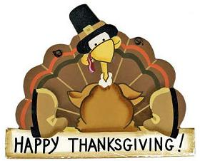
- How were these commands unique in the time they were given?
- What do they say about the character of God?
- How did these impact the people of Israel?
- Why are these important for Christians today?
Physical distance guidelines and wearing masks are required.

