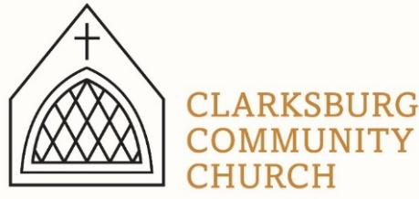
Non-Profit
Bulk Mailing
Clarksburg, CA
95612
Permit #1
Third Class
Chimes
PO Box 36 Clarksburg, CA 95612
52981 Netherlands Road
March 2022

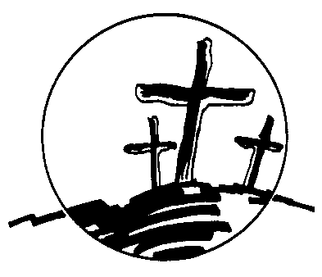
Clarksburg Community Church
Things to Know:

Easter at CCC:
- Maundy Thursday service 6pm
- Good Friday: Sanctuary open all day for prayer
- Sunday Sunrise Service 7am at Scout Cabin
- No Sunday School East Sunday
- Sunday 10 am service (Easter egg hunt following service)
Upcoming Events
- Saturday, April 9: Men’s Group 7a.m.
- Sunday, May 15: Scout Sunday 10:00 a.m.
- Tuesday, April 26: Church Council, 7:00 p.m.
- Sunday June 5: Annual Church Picnic
- June 6-10: VBS 9-11:30 a.m. daily
- June 12: Annual Church Meeting (following service)
Church Contact Information
- Office Phone: 916-744-1422
- Office email: information@clarksburgcc.org
- Pastor Sandy Adams, Jr. – pastorsandy@clarksburgcc.org
- Church Administrator & Children’s Ministry Director, Tiffani Taylor – tiffani.taylor@clarksburgcc.org

*For updates and the link to the church calendar see our website at clarksburgcc.org. To watch the service online please visit our website, www.clarksburgcc.org and click “Watch the Service” or go to YouTube channel, Clarksburg Community Church.

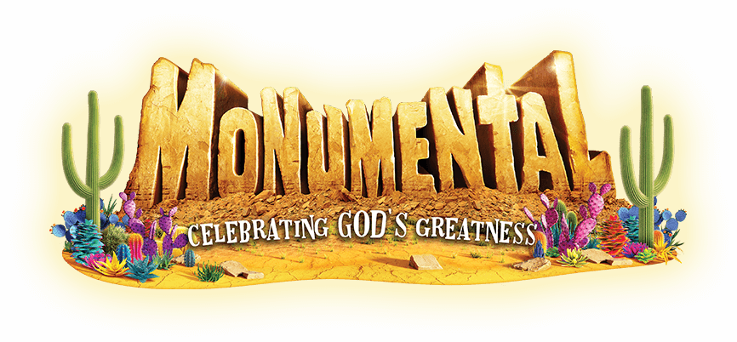
Children’s Ministry
Vacation Bible School: VBS 2022 will be June 6-10 from 9:00-11:30 AM. This year’s theme is “Monumental” and we will learn how big and great our God is! VBS is for children entering Kindergarten through 6th grade. Look for student and volunteer sign-ups soon!

Easter Egg Hunt: There will be a giant Easter Egg Hunt after church on Easter Sunday, April 17. Our teenagers will be hiding Easter eggs for the younger ones. If you would like to donate filled eggs or candy/treats to go in eggs, drop those off in the church office by April 10.

Youth Group
Upcoming Dates:
•Friday April 22: LOCK IN with Arbuckle Community Church in Rocklin
•Sunday, April 24: Regular Youth Group, 4:00-5:30 pm at church.
•Sunday, May 15: Youth group, special speaker, Mrs. Shelton, 4:00-5:30 pm at church.

Summer Camp 2022: It is time for 7th-12th graders to sign up for summer camp! Heavenly Hills Christian Camp is June 19-25. The kids had a blast last year, making friends, singing with the worship band, playing games, swimming, hiking, and learning about their faith! Go to heavenlyhillscamp.org/teencamp.html to check it out and sign up!

Scholarship Recipients:
Clarksburg Community Church is honored to be able to provide $500 scholarships to seniors who have been involved in the church or youth group and are heading off to college in the fall. This year’s recipients are Bethany Taylor, Gracelynn Rapp, and Jack McAllister. Congratulations to these three seniors and the entire class of 2022!

Church Directory
Please provide updated contact information and pictures of your family to information@clarksburgcc.org for the new church directory. Pictures should be clear, visible and in jpeg format. Contact Tiffani in the church office if you have questions.

Annual Reports
Church committee chairs are asked to submit their annual reports to Council Secretary, Peter Finn by May 20th.

“Chiming In” with Pastor Sandy

During this Lent season we offered an eight-week family Sunday School class using a study inspired by hymns and songs of the faith. Most of the songs were centered not just on the crucifixion of Jesus, but the cross itself.

Having Christianity without the cross is impossible. The ultimate purpose for the Son of God becoming human was to die on the cross for the sins of the world. In my opinion, the reason for the time and location of Jesus’ life was because the Roman Empire used the cross for executions. The cross was the most torturous and humiliating way to die, and Jesus chose the most excruciating form of death to give his life as a ransom for many.

In modern times, the cross has been deemphasized because of its “offensive” history and the images it conjures. However, the cross was more offensive to people of the first century than the 21st but was the way God chose to communicate his love and plan of redemption.

The title of the book we used for the study was The Wondrous Cross – borrowed from the great hymn written by Isaac Watts in 1707, “When I Survey the Wondrous Cross.” The hymn compels us to contemplate or “survey” the cross upon which “the prince of glory died.” As Lent 2022 comes to an end and we prepare to celebrate the resurrection of Jesus, remember that before Easter there was Good Friday. We should contemplate the truth Watts stated in the final verse, “Love so amazing, so divine, demands my soul, my life, my all.”

