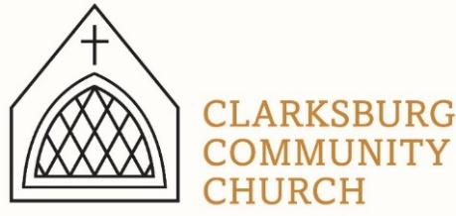
Non-Profit
Bulk Mailing
Clarksburg, CA
95612
Permit #1
Third Class
Chimes
PO Box 36 Clarksburg, CA 95612
52981 Netherlands Ave
February 2023

New Sunday Message Series
February 26th – March 26th

Clarksburg Community Church
Things to Know:

Announcements:
- Lent Sunday School class beginning February 19th.
- Men’s Group is Saturday, March 11 at 7am in the Community Hall.
- Scout Sunday has been moved to May 7th.

Easter at Clarksburg:
- Palm Sunday: April 9 – Sunday School at 9:00 a.m., worship service at 10am, Children’s Choir singing.
- Maundy Thursday Service: April 6 at 7:00 p.m.
- Easter Sunday: April 9 – Sunrise Service 7:00 a.m. at the scout cabin firepit; No Sunday School; worship service, 10:00 a.m.
Children’s Easter Egg Hunt following service.

Church Contact Information
- Tiffani is in the office Monday, Thursday, and Friday from 9am-1pm.
- Church Office: 916-744-1422; Email: information@clarksburgcc.org
- Pastor Sandy Adams, Jr. – pastorsandy@clarksburgcc.org
- Administrator & Children’s Ministry Director, Tiffani Taylor tiffani.taylor@clarksburgcc.org

*Visit our website, clarksburgcc.org, for up-to-date information and to worship with us online. Services can also be found on our YouTube page, “Clarksburg Community Church.”
Construction Update
The remodel of the east wing of the church has begun! Once completed, the large room will host the DECS pre-K program during the school year and the church nursery on Sunday mornings. Church ministries and outside groups will be able to schedule the room for the evenings or any day during the summer. The two restrooms in the back will be updated and a new restroom will be built that is attached to and accessed from the large room. Also, the children’s ministry area upstairs will be getting new energy efficient windows, air conditioning and heat! We are grateful to our trustees and house committee for all their hard work in overseeing and completing this project that will benefit our church and community.

Vacation Bible School
VBS is June 5-9 from 9:00-11:30 a.m. Get ready to blast off into space for a Stellar week where we learn how to shine Jesus’ light to the world! Registration will open after Easter for kids Kinder-6th grade and for helpers 7th grade and up. Look for the link on our website, clarksburgcc.org.

Easter Egg Hunt
There will be an epic Easter Egg Hunt after our 10:00 a.m. Easter Service on Sunday, April 9 for kids 0-12 years old. We need donations of plastic Easter eggs (filled or empty). Please bring donations to the church office before Easter. Kids can meet in the community hall after the 10 a.m. service, and remember to bring a basket for the hunt on Easter! Middle and High School students will be hiding eggs immediately following the service!

Oasis Youth Group
The High School Youth Group kicked off 2023 with a bang (literally banging into things during our 1st-ever Roller Board competition)! We took a group to Thrive Unleashed Teen Conference at Bayside Church, where they enjoyed speakers, concerts, food trucks and games. Coming up next:
- Winterfest Weekend Retreat at Heavenly Hills Camp February 18-20th. We are excited for a weekend of worship and fellowship for our teenagers.
- Sunday, March 5th from 4:00-5:30 p.m. BINGO! With great message and prizes.
- Sunday, March 26th from 4:00-5:30 p.m. Fun and Fellowship at the church
Church Missions
Two ministries have been added to our missions giving for the next three years: Andrew and Rachel Ahr with Athletes in Action (AiA) at UC Davis, and Bethany Slavic Church’s ministry to Ukrainian refugees in Sacramento.
Community News
The Delta High School Drama Club will be presenting the Disney Musical Aladdin, on March 23 and 24 at 7 p.m., and March 25 at 12 p.m.. Many of the youth from our church are involved, so come out and support our teens.
For ticket information go to Deltadrama.ticketleap.com.

Upcoming Meetings/Events:
- Knitters Club meets on Thursdays from 10:00 a.m – noon in the Music Room
- Monday morning Women’s Bible Study at 9:30 a.m. in the Music Room
- Chancel Choir rehearsal is Wednesday from 7:00 – 8:00 p.m. and welcome to all
- The next Church Council meeting is February 28 at 7:00 p.m.

“Chiming In w/ Pastor Sandy”
Beginning February 19, I will be leading a family Sunday School class based on the study New Life Rising: Devotions on the Journey from Death to Life. This seven-week study will confront what we hold dear in life that needs to “die” in order for us to experience the fullness of life in Jesus Christ. Books are free for all adults, middle school and high school students who attend.

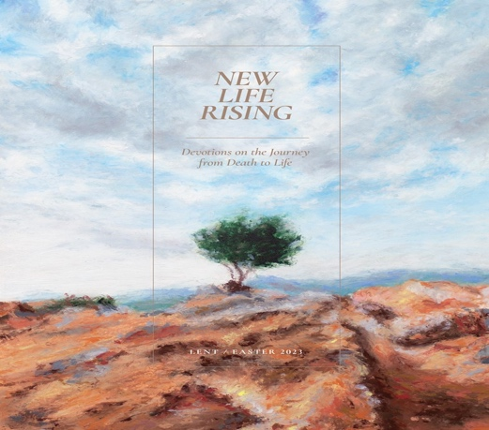
Lent Family Sunday School Class
February 19th – April 2nd
9:00 a.m.

