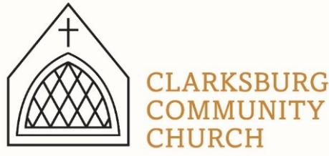
Non-Profit
Bulk Mailing
Clarksburg, CA
95612
Permit #1
Third Class
Chimes
PO Box 36 Clarksburg, CA 95612
52981 Netherlands Ave
November 2022

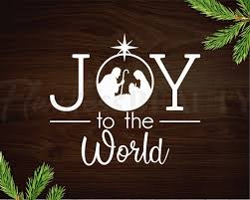

Clarksburg Community Church
Things to Know:
Christmas at Clarksburg:
- Christmas Decorating Party, Friday, November 25 at 9:30am. Come help decorate the church for the Christmas season and enjoy fellowship, Christmas music and light refreshments. Sign-up sheet is in the foyer or contact Tressa at 916-873-2961.
- Parents Night Out Event, Sunday, December 4 from 3-7pm.
- Sunday, December 18 Christmas Concert at 6pm. If you would like to participate with the choir, or contribute your own music piece, please contact Keith Connor.
- Christmas Eve service from 7-8pm on December 24.
- Christmas Day service at 10am on Sunday, December 25. Join us for an uplifting Christmas celebration with music and message to start your Christmas day off with Jesus at the center. (No Sunday School this day.)

Small Groups:
- The Monday women’s Bible study is from 9:00-11:00 a.m.
- Men’s Group Saturday, December 10th at 7:00 a.m.

Church Contact Information
- The church office is closed on Tuesdays. Tiffani is in the office Monday, Thursday, and Friday from 9am-1pm.
- Church Office: 916-744-1422; Email: information@clarksburgcc.org
- Pastor Sandy Adams, Jr. – pastorsandy@clarksburgcc.org
- Administrator & Children’s Ministry Director, Tiffani Taylor tiffani.taylor@clarksburgcc.org

*Visit our website, clarksburgcc.org, for up-to-date information and to worship with us online. Services can also be found on our YouTube page, “Clarksburg Community Church.”
Care & Concern Committee
The Care & Concern Committee provides meals for people in our community due to illness, recovery from surgery and hospitalization of family members. Over the past couple of years, requests for “meal trains” slowed down, but have been increasing recently. Whether you would like to continue being part of this ministry or joining for the first time, please sign-up at the Main Entrance or email me at sunlover.ds@gmail.com. Also, if you have questions about this ministry before signing up, please email me. Thank you in advance for your consideration in serving your community this way. Blessings, Dee Slater

Parent’s Night Out:
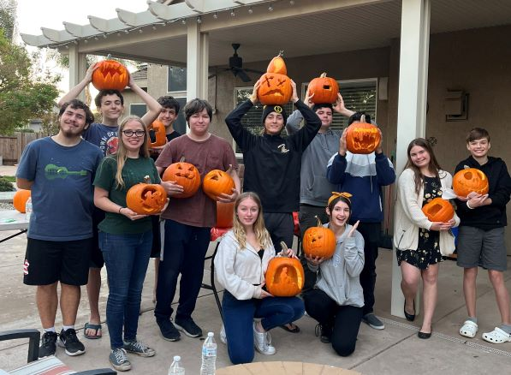
Mark your calendar for December 4 from 3-7pm for our Parent’s Night Out hosted by children’s ministry and the high school youth group. Parents will be able to drop off their preschool through 6th grade children at the church at 3pm for an afternoon of singing, crafts, pizza, games and more. Parents can enjoy some kid free Christmas shopping time and pick up children by 7pm.

High School Group:
The pumpkin carving afternoon hosted by the Bonilla family was a success!

Upcoming events:
December 4 from 3-7pm, Parent Night Out helpers.

December 11 Christmas party from 4-5:30pm at the church.

Congratulations:
Sandy Burlando and Paul Hale were married in Clarksburg Community Church on October 22. Congratulations to them as they begin their life together.

Anniversaries:
Raquel Rapp is compiling a list of wedding anniversaries. Email her at rapprloves2scrap@yahoo.com with yours if she hasn’t talked with you already.
“Chiming In w/ Pastor Sandy”
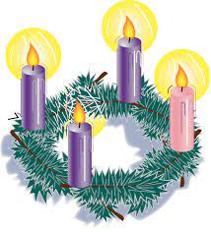
The four Sundays before Christmas, known as “Advent,” are meant to prepare Christians as we celebrate Jesus’ first arrival and anticipate his second. During the Advent season, we will be offering a family Sunday School class using the study guide The Promised One. The class is open to all adults and middle school through high school students, and everyone will receive a book for free. We hope you will join us these four Sundays at 9:00 a.m. We will be discussing the following four themes:
November 27th: “Mighty God”
December 4th: “Prince of Peace”
December 11th: “Light of the World”
December 18th: “Immanuel”

This is one of those years when Christmas and New Years are on Sunday, which always leads to questions about our worship schedule. It’s simple: Christmas Eve service will be Saturday the 24th at 7:00 p.m. Sunday, December 25th and January 1st, there will be no Sunday School, but worship still take place at 10:00 a.m.

May this holiday season be the best one yet as we celebrate life’s joys and God’s blessings!

Church News
•We are adding two new ministries to our missions giving for the next three years: Andrew and Rachel Ahr with Athletes in Action (AiA) at UC Davis, and Bethany Slavic Church’s ministry to Ukrainian refugees in Sacramento.

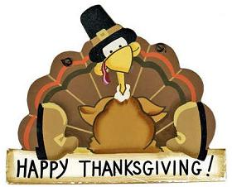
•On November 6th, the church membership voted to approve the proposed Bylaws from the Bylaws Review Committee and Church Council. Anyone needing a copy of the new Bylaws please email information@clarksburgcc.org.

•Pastor Sandy will be hosting a baptism class on Sunday, December 8th at 3:00 p.m. The class is open to anyone interested in baptism and parents of children of all ages.

•Membership classes will be offered once again in 2023 and will be announced soon.

